**NOTES:**

Ht1maindisplay

Packages1

Ht2maindisplay

Packages2

BuildingLink Communications Public Display to change names, PWs, etc.

On display settings to change icon size

WiFi

HT-NET / ironside

HT-Conference / Trustees10

HT-Meeting/Tru10 via Starry admin/HookDebonair1667/192.168.99.1

GoDaddy

25659814 Tower2trustees,

Trustees10 HT 6585

htonline FTP Trustees@10 HT, DB

harbortowersonllne@gmall.com /HTnetwork@85

PDF HTDoc199#

VNC

Click on VNC icon upper right, to open VNC window then License for where to connect

[harbortowersone@gmail.com](mailto:harbortowersone@gmail.com) T1 Trustees10

[harbortowerstwo@gmail.com](mailto:harbortowerstwo@gmail.com) T2

Gns/T10

T2P 10.1.10.56 b8:27:eb:82:ad:3a 10 httwo

T2MR 10.1.10.85 b8:27:eb:48:6a:0f 10 httwo

T2LR 10.1.10.65 b8:27:eb:81:fb:13 10 httwo

T1P 10.1.10.68 b8:27:eb:96:5e:5e 10 htone

T1MR 10.1.10.71 b8:27:eb:99:ba:50 10 htone

T1LR 10.1.10.66 b8:27:eb:96:5e:5e 10 htone

Terminal History

/home/pi/.bash_history

**Github**

Status

Pull

Add

Commit

Commit -a

Push

## File Server: Set up Samba

sudo apt-get update

sudo apt-get upgrade

sudo apt-get install samba **samba-common-bin**

**Create your shared directory**

We’re going to create a dedicated shared directory on our Pi’s micro SD hard disk. You can put it anywhere, but ours will be at the top level of the root file system.

## sudo mkdir -m 1777 /share

This command sets the sticky bit (1) to help prevent the directory from being accidentally deleted and gives everyone read/write/execute (777) permissions on it.

### Configure Samba to share your new directory

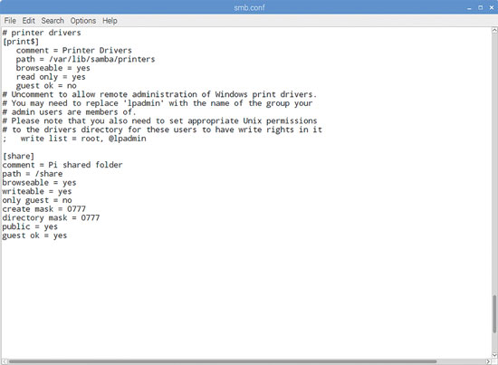

Samba Config files

Edit Samba’s config files to make the file share visible to the Windows PCs on the network.

## sudo nano /etc/samba/smb.conf

In our example, you’ll need to add the following entry:

## Workgroup EMC

[homes]

comment = Home Directories

browseable = no

# By default, the home directories are exported read-only. Change the

# next parameter to 'no' if you want to be able to write to them.

read only = no

# File creation mask is set to 0700 for security reasons. If you want to

# create files with group=rw permissions, set next parameter to 0775.

create mask = 0775

# Directory creation mask is set to 0700 for security reasons. If you want to

# create dirs. with group=rw permissions, set next parameter to 0775.

directory mask = 0775

## [share]

## Comment = Pi shared folder

## Path = /share

## Browseable = yes

## Writeable = Yes

## only guest = no

## create mask = 0777

## directory mask = 0777

## Public = yes

## Guest ok = yes

This means that anyone will be able to read, write, and execute files in the share, either by logging in as a Samba user (which we’ll set up below) or as a guest. If you don’t want to allow guest users, omit the guest ok = yes line.

You could also use Samba to share a user’s home directory so they can access it from elsewhere on the network, or to share a larger external hard disk that lives at a fixed mount point. Just create a smb.conf entry for any path you want to share, and it’ll be made available across your network when you restart Samba.

### Create a user and start Samba

Before we start the server, you’ll want to set a Samba password - this is not the same as your standard default password (raspberry), but there’s no harm in reusing this if you want to, as this is a low-security, local network project.

sudo smbpasswd -a pi

Then set a password as prompted. Finally, let’s restart Samba:

sudo /etc/init.d/samba-ad-dc restart

From now on, Samba will start automatically whenever you power on your Pi. Once you’ve made sure that you can locate your shared folder on the network, you can safely disconnect the mouse, monitor, and keyboard from your Pi and just leave it running as a headless file server.

### Find your Pi on the network

You’ll now be able to find your Raspberry Pi file server (named RASPBERRYPI by default) from any device on your local network. If you’ve left smb.conf’s default settings as they are, it will appear in a